Anton Shpigel amury@hotmail.com
Deerfield Beach, FL 33064
Tel. 917.686.5657

SUMMARY:

- PMP certified, senior-level professional with an extensive 20-year career in global IT Project Management, practicing variety of methodologies including Agile, SAFe Agile, Waterfall, Kanban, Hybrid, ITIL, SDLC, within the following sectors of Information Technology industries: Finance, Banking, Hospitality, Computer Software, Foreign Exchange, Mortgage, Hedge Funds, Telecom, Pharmaceuticals, Retail, Advertising and Public Relations.

- A seasoned Information Technology professional with overall diverse experience managing Infrastructure and Software projects including Implementations, New Builds, Designs, Go Live, Business Continuity, Disaster Recovery, Migrations, Upgrades, Role Swaps, Decommissions, Datacenter build outs, and Virtual Cloud Computing projects with substantial budgets.

EDUCATION:

Long Island University Dec 1998
Bachelor of Science in Computer Science
Salinas Group, Ltd Jan 2001
Nokia Internet Communications Education
Certificate of Nokia Security Administrator
Check Point – Firewall-1, VPN-1 Management, Course 1
Check Point – Firewall-1, VPN-1 Management, Course 2
TACT Project management PMI Essentials Feb 2017
PMP: Project Management Institute, Project Management Professional Jan 2023

TECHNICAL SKILLS:

Operating Systems: VMware, Azure, Windows Server, Windows, AWS, MS DOS, Citrix, Cisco IOS, JUNOS, Nokia IPSO, RHEL, CentOS, Free BSD, Linux, Unix, Mac OS, Android.
Software: Active Directory, IIS, DNS, SQL Server, Exchange Server, SharePoint, Office Suite, Office 365, Adobe Suite, Visual Studio, VMware vCenter and vSphere, Veam, Fusion, SNA Server, Oracle, Novell NetWare, IBM WebSphere, Bloomberg, Reuters, Symantec, JIRA Modules, Salesforce, Seagate Crystal Reports, WebTrends, Lyris.
PM Tools: Smartsheet, Confluence, ServiceNow, Atlassian JIRA, Microsoft Office, Project, Visio, Excel, OneNote, Power Point, SharePoint, Adobe Suite, Tableau, Slack.
Security Tools and Controls: Sophoss Endpoint Protection and Safeguard, McAfee Web Gateway and Protection, Microsoft System Center controls, Check Point, Websense, SurfControl, ISA, WebTrends, Silent Watch, Mimesweeper, Symantec (Axent) NetRecon and Bindview Hackershield, Internet Security Systems: Internet Scanner, Network Associates: CyberCop Scanner, WireShark, NMAP.org
Hardware: Acer, Apple, Asus, Avaya, Blue Coat, Bloomberg, Cisco, Compaq, Dell, Hewlett Packard, EMC, Fortinet, F5, IBM-compatible, Juniper, Reuters, Sony, Samsung, Nokia, Palo Alto, Xerox, Canon, Hitachi and Toshiba.
Networks: Fiber Optics, WiFi 5G, Token Ring, Frame Relay, OC-3, T1, DS0,1,3, E1, 802.3, 802.11.
Protocols: TCP/IPv4v6, MPLS, BGP, OSPF, EIGRP, IGRP, RIP, FIX, Fibre Channel, IPsec, SOCKetS, IPX, SPX, X.25, ISDN, SAP, AppleTalk.
Development Technologies: SQL, PHP, ASP, ASP.Net, JAVA/JDK, JavaScript, HTML, VISUAL C++, ODBC, SDK,Jrun.

AREAS OF EXPERTISE:

• IT Project / Program Management
• Infrastructure - Enterprise Architecture
• IT Security / Cybersecurity
• IT Governance / Strategy
• Project Management Office (PMO)
• Risk Management and Compliance
• Network Administration
• Cloud Computing
• Market Data
• Virtualization
• Application Development
• IT Service Management
• Operations Management
• Data Center Management
• Technical Diagram and Flow Chart Design
• Business Continuity
• Information Systems and networks

WORK EXPERIENCE:

Seminole Hard Rock Support Services, FL Jan 2021 – Present
Senior IT Project Manager [Contract]

- Managed the launch of Hard Rock’s global “Unity” program with over 74 countries, including 172 cafes, 37 hotels, and 10 casinos to incorporate the world class universal loyalty card experience for its customers with budget over 100M.
- Managed Unity program Go Live for the following existing and new properties: Mirage Las Vegas, Atlantic City, New York City, Florida SGA, Sacramento, Bristol, Rockford, Cincinnati, Northern Indiana, and Punta Cana.
- Key Accomplishments: Designed, planned and built Unity’s new Enterprise Lab to test Unity products within the following environments: Development, QA, Staging, and Training for E2E, Integration, UAT, Security, Performance and regression activities.
- PMO liaison, schedule and resource manager to Infrastructure, IT Security, Operations, Database, System Administrators, Network Engineers, Telco and iSeries teams.
- Vendor management included maintaining close working relationships with Light and Wonder (Scientific Games), House Advantage, Bally Casino Market Place (CMP), Everi, Salesforce, Acoustic, Accumail, Redline, POS Micros, POS InfoGenesis, PMS Agilysys, iReckonU, Softpoint, Seven Rooms, Open Table and Windsurfer CRS.
- Other projects included: Hard Rock Sportsbook, HALo High Availability, Patron p360 Systems Decommission, iVeiw Consent deployment, Role swap failover.
- Excellent communication & presentation skills working with C-Level executives; strong facilitation skills, excellent interpersonal & conflict resolution skills.
- Strong experience with preparation and maintenance of essential project documentation such as Project Plans, Scope, Charters, Design documents, Risk logs, Status reports, Communication Plans, Develop and maintain project schedules.
- Proactively communicate project status and risks to all stakeholders and be prepared to take corrective action including Change Control to address concerns and challenges.

New York Faces Magazine, New York Jan 2019 – Dec 2020
Senior IT Project Manager [Contract]

- Managing COVID-19 response by analyzing company’s systems, developing policies and procedures to ensure business continuity and enhance company’s pandemic preparedness strategy and compliance.
- Managing development, migration and deployment of new online products including a website to replace an existing outdated site due to company's change in the line of business.
- Building a self-autonomous site with an ability to sustain itself with minimum human interaction and formatting the site for use on mobile devices and payment processors, using SCRUM and SDLC process.
- Responsibilities include Schedule, Cost, Quality Assurance, Risk, Resources and Scope management.
- Managing a virtual team of developers, designers, IT professionals and delivering metrics, analytics and estimations.
- Technologies implemented include SQL, Php, Flash, HTML, Java and payment processing technologies.
- Project includes QA of releases using Waterfall methodology in Azure environment and Agile framework releases using sprints of 2 to 3 weeks.
- Providing Technical contribution to the team including Incident & Problem Management, Change Management, Release Management and Knowledge Management using Jira, Confluence, MS Project and SharePoint.

Wells Fargo Securities, LLC. New York Oct 2016 – Oct 2018
IT Project Manager / Technical Project Manager [Contract]

- Responsible for all aspects of Enterprise infrastructure management, migration, connectivity, business continuity, implementation and support for Wholesale Banking Technology group, Equity Cash/Trading/Capital Markets.
- Migrated New York City Wells Fargo locations to new Hudson Yards. Moved multiple data-center locations to co-locations including mission critical Applications, Network Devices, and Employees. Moved trading floor desks: WATS, CASH, SWAP, ETF, PT, CONVERTS and DERIVATIVES including PROD, DEV, BCP, UAT and SIT environments.
- Planned, created and designed Network Diagrams, Network infrastructure architecture, Application data flow and Datacenter builds. Designed security diagrams for Application OMS platform, Trading Application data flow diagrams, infrastructure layout illustrations, connectivity maps, detailed visual figures and graphics.
- Responsible primary implementation specialist for Migration, End of Life, Refresh, Decommission, Data destruction and archiving, Cross Connects, CAW etc. for TRADEWARE SS&C, NASDAQ, BLOOMBERG, REUTERS AUTEX, SUNGARD, IPC, SFTI, CME, IEX, ISE, EBS, One Chicago, Radianz and more.
- Connectivity support, Migration and Implementation for the following (OMS) Order Management System Technologies: FLEX TRADE, FIDESSA, CLIENT ROUTER, NOVA, ALGO, CLIENT and EXCHANGE GATEWAYS, BRASS, VOV, SAMI, DTS, VTC and FIX Engine. Creating data flow diagram design chart and documentation.
- Support FIX team, CASH Desk, WATS Desk, SWAP Desk, ETF/PT, CONVERTS, DERIVATIVES engineers for connectivity. Project managed the installation of multiple T1, T3, OC 48 circuits, SONET Ring at WF datacenters.
- Point of contact for Equity team to external technical silos including DCM team for Colo migration to various sites including NY4 PICO, SBLD NY, PLAZA PHL, SILAS NC, OXMOOR AL, SVDC MN, WEC NC, CARTERET NJ and ASHBURN VA.
- Working closely with all stakeholders and engineering partners as Point of Contact including Project Management, Service Management, Product and Service Management, Implementation Relation Management, Technology Management, Technology Relationship Management, Data Center Management, Platform Engineers, Information Security Officers, Security Firewall engineers, Network perimeter engineers, Business System Consultants, Market Data Services, Fulfillment Management and Operating System Engineers.

Recent managed special projects included:
  - PROJECT SHIELD: Migrate all vulnerable networks and applications into DCAM zone to achieve compliance as per new Project Shield Technology Refresh initiative. Utilizing Network Security policy, analysis and enforcement to deploy an additional layer of security known as PAA zone between the developers and DMZ. Design Data Flow collaboration diagram and new security plan in order to move all dependent applications.
  - VPN IKE Version 2 upgrade deployment: Manage, deliver and upgrade current Wells Fargo VPN encryption model to meet today’s encryption technology standards. Implementing and upgrading from current version 1 of (IKE) Internet Key Exchange protocol to version 2 on an enterprise level including SILAS, OXMOOR and SVDC data centers.
  - LATENCY: Manage, create, and implement a project plan to track OMS latency using ITRS and CORVIL systems to deliver round trip latency results in an orderly organized fashion using FIX tag protocol technology. Deliver tools to create and analyze accurate End of Day Latency reports.
  - SUNGARD BRASS CASH Application Decommission (EOL): Managed RCAA legal approval and application user deletion. Created ACE Recommendation and decommissioned 1BRA servers. Performed data back up and data archiving for past 7 years using Documentum. Deployed firewall rules and filtered policies.
Deutsche Boerse Group. New York Mar 2014 – Sep 2016
IT Project Manager / Infrastructure Project Manager

- Responsible for delivering 360T TEX Java enterprise trading platform and its various management tools used for trade investigations, trade timeouts, critical trade errors, pricing servers, trade importers, pricing adapters, client mappings, trade exports, on-boarding, white labels, bank cross connects and trade network equipment at EQUINIX NY4, London UK and Frankfurt Germany datacenters.
- Managed Verizon VOIP telecom system upgrade projects and PBX phone system upgrade.
- Equinix NY4 – supported trade network equipment at NY4 Equinix datacenter.
- Equinix NY4 – managed bank cross connects. Created scope, schedule, compliance and risk avoidance plans.
- Branch Infrastructure – delivered new Dell VRTX server, Juniper SRX240 firewall, Cisco routers with backup LTE wireless cards, Exchange 2010 server, APC XL UPS, Wi-Fi, VPN Radius client.
- Verizon – added new 10 Mbps data circuit, T1 phone circuit and land lines.
- Polycom – deployed new Polycom IP 650 phone system: programmed phones, configured group line sharing, ported numbers and managed Verizon phone system administration.
- Dell – deployed new OptiPlex 3020 workstations and M3800 self-encrypting SSD laptops.
- Dispatcher Queue – provided tools to manage busy support queue.

FHP Inc. New York Oct 2004 – Feb 2014
IT Infrastructure Project Manager

- Managed Disaster Recovery efforts after Hurricane Sandy Datacenter outage.
- Responsible for deployment and migration of Windows Server 2012, Windows 7 and Virtual Machines.
- Deployment of HP BLC3000 and BLC7000 blade enclosures with BL460C and D2200SB Storage Blades in VMware 10 GbE environment. Deployed Cisco C2960S switches, Juniper SRX Firewalls, Juniper EX switches, EMC VNX, HP MSA Fibre Channel SAN Arrays, APC Symmetra UPS systems and Cisco 7975G IP phone systems.
- Migrated company from Windows 2003 environment to Windows Server 2012 R2 Active Directory environment, Exchange 2010, SharePoint 2013, SQL 2014 and IIS 8.5
- Configured physical Cisco products with virtual products in VMware and Hyper-V virtual environments and switches within a multi-tier infrastructure for DMZ and network segmentation including advanced routing and switching protocols BGP, IPSEC, Spanning Tree, VLAN tagging, TRUNK and ETHER CHANNEL.
- Installed, configured and administered all Windows Server 2012 R2: DNS Servers, DFS Servers, FSMO Servers, Domain Controllers, Printer Servers, and DHCP.
- Secured sensitive network segments including Wi-Fi devices, DMZ zones, VPN accounts, Self-Encrypting devices, VLANs, DHCP. Increased layers of security and authentication.
- Moved corporate offices post hurricane Sandy including network equipment, servers, workstations and communications. Disposed of damaged and flooded equipment.
- Migrated company from Check Point environment to Juniper SRX 240, 650 and 1300 series firewalls. Implemented 50 client Dynamic VPN access for mobile users using Duo two-factor Active Directory authentication. Supported site-to-site VPN networks between New York, Chicago, Mexico, Brazil and Germany.
- Administered company's web hosting servers, SharePoint, Cirtix and media servers. Maintained company's marketing databases and scheduled mass mailings using Lyris.
- Key Accounts: Verizon, Prudential Financials, Canon USA, BioReference Laboratories, Think Smart, Inc, Liz Claiborne, The Montgomery Group, August Silk, eDigitalMall, and Liquid Holdings Group.

Madge Networks. New York Nov 2001 – Sep 2003
Senior Information Systems and Network Security Administrator

- Managed a 24x7 mission critical security operations data center.
- Responsible for deployment and audit of system security, infrastructure and integrity.
- Managed installation, configuration and support of critical Datacomm devices, routers and switches, Nokia firewalls 300/400/600/710, Cisco routers 7500/3600/2600/1600/800, Cisco Switches 6509/5500/2900/1900, Alteon security switch load balancers, Nortel Contivity VPN Switches 1500/2500, IPass Roam Servers, RADIUS and web servers.
- Major projects included network design and deployment for Cunningham Communications, TradingLinx, Planet Hopper, Trade Capture, Invocare, Brann Forbes, and Modelwire.
- Responsible for ongoing oversight and development of infrastructure and architecture.
- Designed lab infrastructure to test firewalls, biometric authentication, web caches, proxies, and intrusion detection systems.

Zentropy Partners, Inc. (McCann-Erickson) New York Feb 2000 – Nov 2001
Manager of Information Systems

- Managed and supported MS Windows and Mac OS mixed network environments for a medium size advertisement firm of 600+ employees worldwide.
- Responsible for company’s LAN, WAN, Intranet, wireless and telecommunication operability and functionality.
- Managed all activities of the IS department including network operations group and user support team. Managed and developed strategies for numerous office infrastructure mergers, migrations, consolidations and closings.
- Responsible for company’s Windows and Mac multiplatform network with services including 100/1000 Mbps network, clustered web, SQL database, exchange, file, DHCP, DNS, WINS, RAS, SNA, FTP, proxy, print, Unix OS and Mac OS servers.
- Major projects included the network expansion of accounting systems, information systems and web development departments. Acquisitions of new equipment and services. Developed ticket driven user support express system.
- Key Clients: The Coca Cola Company, Brooks Brothers, GM, OPEL, Price-Waterhouse, Sprint, Dean and Deluca, J Crew, L’Oreal, and Dun & Bradstreet.

Angotti, Thomas, Hedge, Inc. (McCann-Erickson) New York Jun 1998 – Feb 2000
Manager of Information Systems

- Managed and supported multiplatform network environment for a mid-size advertisement firm of 400+ employees. Managed Y2K compliance program and insured for delivery of Y2K remediation solution. Company’s relocation project involved network relocation, software migration, fiber optics installations and deployment of new network infrastructure.
- Responsible for project staffing, schedules, budgets, hardware/software evaluations, quality assurance and technical training.

Anderson & Lembke, Inc. (McCann-Erickson) New York May 1995 – Jun 1998
Senior System Administrator

- Responsible for all aspects of system administration proficiency in a multiplatform environment including analysis, design, development, implementation, documentation, evaluation and budget allocation. Network administrator with vast hands-on experience in identifying and designing effective solutions to meet the current needs and future businesses expansion.
- Supported and maintained Web, Database, Email, DHCP, DNS, FTP, Proxy, Print services. Maintained critical network devices including routers, switches, servers, and phone system.

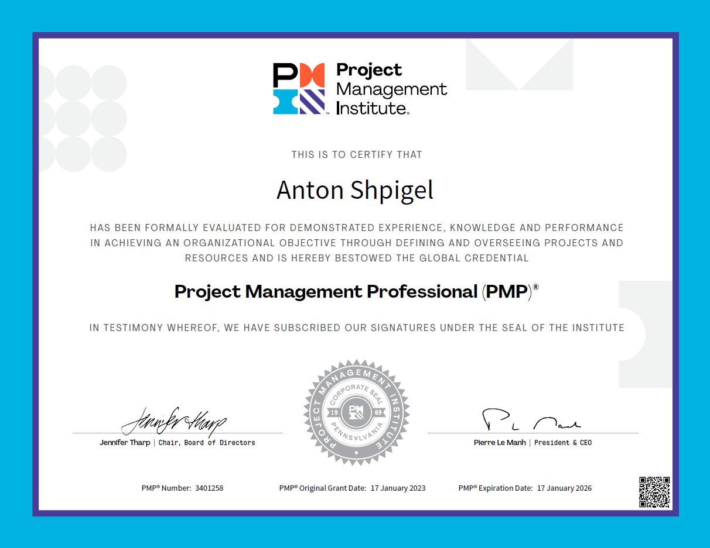

SKILLS:
• | IT Project Management | 20 years
 | Program Management | 10 years
 | PMO | 10 years
 | Agile Project Management | 10 years
 | Risk Management and Compliance | 12 years
 | IT Audit | 8 years
 | Market Data | 8 years
• | Enterprise Infrastructure Architecture | 28 years
 | Network Administration | 23 years
 | Cloud Computing | 16 years
 | Cybersecurity | 16 years
 | Virtualization | 12 years
 | IT Service Management | 23 years
 | Operations Management | 23 years
 | IT Strategy | 12 years
 | Service Delivery Management | 8 years
• | Business Continuity | 14 years
 | Disaster Recovery | 14 years
 | Network Security | 16 years
 | FIX Connectivity | 6 years
 | Analytical Skills | 14 years
 | Technical Diagram and Flow Chart Design | 11 years
 | Data Management | 14 years
 | Databases | 14 years
• | Software Project Management | 6 years
 | Quality Assurance | 10 years
 | Production Management | 9 years
 | Platform Management | 8 years
• | IT Consultant/ Analyst | 14 years
 | Business Intelligence Management | 8 years

CANDIDATE DETAILS:
Legal Name | Anton Shpigel
Contact number | 1-917-686-5657
Email ID | amury@hotmail.com
Skype ID | antonshpigel
LinkedIn | linkedin.com/in/ashpigel
US work authorization | US Citizen
Current Location (City and State) | Deerfield Beach, FL 33064
Hourly Rate | Starting at $90/hr, C2C
Travel | Remote Work
Earliest Joining Date | 1-week notice
Availability for Interviews | 24 hours
SS | XXX-XX-X513
DOB | 26-Oct

